Smoking Does Not Belong in the Workplace

Anthony Meunier

Business Audience, Colleagues, Management

Introduction

We are all entitled to our freedom of choice. Some people choose to smoke, while others do not. One thing that is undisputable, however, is the fact that smoking damages your body and leads to adverse effects on health. Smoking is a choice that, when done in public, affects not only your health but also puts others at risk to suffer the consequences and negative effects of this bad habit. The health problems associated with cigarette smoking have a great impact on the workplace too. Not only are there increased medical care costs incurred by employers due to smoking-related health issues, but concerns of productivity are called into question as well.

Thesis Statement

Smoking is harmful to one’s health. It also creates detrimental and unconsidered side effects that simply do not enhance or belong in the workplace. This is precisely the reason I propose that we pass this petition to ban smoking in all areas of company property. In order to ensure our employees stay healthy and productive contributors to this company, I feel it is absolutely crucial and necessary to implement this ban.

1. Negative health effects of smoking
2. Tobacco use leads to disease, disability, and death
3. Single most preventable cause of both morbidity and premature death in the U.S. 19% of adults smoke and 443,000 deaths as result each year.
4. For every person that dies from smoking, about 30 more suffer from at least one serious smoking-related illness
5. Community and environmental impact
6. Secondhand smoke can cause heart disease, lung cancer, asthma and respiratory infections in non-smokers
7. 1.69 billion pounds of cigarette butts end up as waste each year; 18.6 billion trees consumed in producing cigarettes = bad image for business
8. Workplace impact of smoking
9. Increased absenteeism and decreased productivity
10. Tobacco-related illnesses lead to time missed; 33% more likely to miss work than non-smokers
11. Smoke breaks average between 15-30 minutes of lost work time each day per employee
12. Financial implications of employee smoking
13. Increased insurance/health care costs paid by employer – disability and premature mortality caused by smoking over $47 billion/year
14. Less dollar amounts in revenue generated by smokers versus non smokers
15. How can we minimize effects and make positive changes?
16. Steps to a smoke-free workplace
17. Implement no smoking policy & detail benefits of a tobacco-free workplace (healthier, safer, lower risks, etc.)

2. Provide quit smoking programs and encourage change in behavior. Studies show when there is more opportunity and resources to quit, smokers are more successful at quitting.

Conclusion

Smoking not only causes cancer but is also one in itself when it comes to the workplace. In order to create a better, healthier and more productive work environment, removing smoking from the daily agenda is without a doubt the key step in helping achieve and further these goals. Through both policies and positive encouragement, this company can help itself by helping its employees lessen or even quit smoking altogether. So let’s all consider the exponential benefits of implementing this no smoking policy and sign the petition – it’s the right thing to do for your company, your peers, and most of all for yourselves!

Visual Explanation

This graph is from a study that was conducted as means to interpret productivity of smokers vs. non-smokers. Specifically this graph compares the difference between former smokers and current smokers, and rates their productivity value in terms of efficiency, quality, and amount work. They assign values to themselves, and then also from the perspective of their coworkers and supervisors. When viewing themselves, current smokers view themselves as about as productive as former smokers. However, coworkers and supervisors have a different perspective and often view current smokers as much less productive than former smokers.

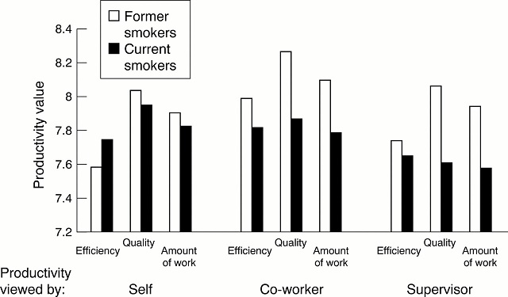

This chart is a breakdown of the 443,000 smoking related deaths each year in the United States. Contrary to popular belief, smoking affects the heart just as much as it affects the lungs; they are both virtually even in terms of number of deaths each year due to smoking. It also visually indicates that smoking has many other affects as well that can lead to death such as cancer, stroke, and pulmonary disease. This chart is for years 2000-2004, so it is very likely that the numbers have increased even more in the last 10+ years.

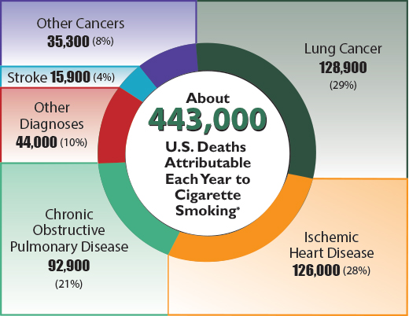

References

American Cancer Society. (2013). Tobacco use in the workplace: a model policy. Retrieved from <http://www.cancer.org/healthy/stayawayfromtobacco/smoke-freecommunities/createasmoke-freeworkplace/smoking-in-the-workplace-a-model-policy>

Fox, M. (2013). Smoking employees cost $6,000 a year more, study finds. Retrieved from <http://www.nbcnews.com/health/health-news/smoking-employees-cost-6-000-year-more-study-finds-f6C10182631>

Halpern, M., Shikiar, R., Rentz, A. M., & Khan, Z. M. (2001). Impact of smoking status on workplace absenteeism and productivity. Retrieved from <http://tobaccocontrol.bmj.com/content/10/3/233.full>

Mayo Clinic. (2012). Secondhand smoke: avoid dangers in the air. Retrieved from <http://www.mayoclinic.org/healthy-living/adult-health/in-depth/secondhand-smoke/art-20043914>

Patterson, S. (2012). Smokers miss more work, study shows. Retrieved from <http://www.webpronews.com/smokers-miss-more-work-shows-study-2012-11>